## Planning Commission Staff Report

**To**: City Council

**Respectfully Submitted**: Klara Beck, Community Development Manager **Date:** June 27, 2023

**Subject**: V-2023-1

### REQUESTED ACTION

Approve a variance for an accessory structure with a footprint greater than 10% of the lot size on a nonconforming lot at 647 W Stanton Ave as recommended by the Planning Commission following a public hearing at their June 26 meeting.

### GENERAL INFORMATION

|  |  |  |  |
| --- | --- | --- | --- |
| ***Applicant*** | TABITHA HALLAN ET AL | ***Planning Commission Hearing*** | June 26, 2023 |
| ***Property Owner*** | TABITHA HALLAN ET AL | ***City Council Meeting*** | July 3, 2023 |
| ***Address*** | 647 W Stanton Ave | ***Application Date*** | June 8, 2023 |
| ***Parcel Number*** | 71-003-99-0986-000 | ***60-Day Expiration Date*** | August 31, 2023 |
| ***Zoning*** | R-4, MULTIPLE-FAMILY RESIDENCE DISTRICT |  |  |

**BACKGROUND**

#### Site Information & Current Conditions

The city was contacted by the owners of 647 Stanton Ave W to consider a variance to city code restricting the footprint of accessory structures to 10% of the lot. 647 Stanton Ave W is located in an R-4 zone in an old part of town. Where a lot has less area than required by code but was “of record” at the effective date of our zoning code, the lot is considered to be legally nonconforming. The parcel is 0.08 acres, or a size of 3,443 square feet, and the existing home is 744 sq ft. Per § 154.034 R-4, MULTIPLE-FAMILY RESIDENCE DISTRICT, (6) Lot area regulations, “the minimum total lot area per dwelling unit shall not be less than 2,500 square feet… The minimum total lot area shall not be less than 10,000 square feet.”

In contrast, surrounding parcels are 2-3x as large. A shed is currently located in the back ⅓ of the lot. That structure will be removed and replaced with a new 24’ x 36’ garage. The property owners propose to use the property in a reasonable manner not permitted by the zoning ordinance. The variance, if granted, will not alter the essential character of the locality.

#### Adjacent Zoning

To the south is I-2 zoning (though the uses are residential). To the north and continuing to the east is the R-4 zone in which the home is located. To the west is R-2.

#### 3-1: 647 W Stanton Ave

**Adjacent Uses**

Page **2** of **3**

Adjacent uses are residential. A railroad track runs nearby. The Port Authority-owned former dairy property is between the residential district and the river. The Port Authority seeks to redevelop the former dairy site for housing.

#### Proposed Project

The applicants state their intention is to build a 24’x 36’ garage on site, removing the existing shed and expanding the footprint for a garage.

#### Public Notification & Comments

A notice of the public hearing was published in the *Daily Journal* on June 14, 2023. A copy of the public hearing notice was mailed to 36 property owners within 350’ of 647 W Stanton Ave.

### PROPOSED FINDINGS

§154.017(B)(4)(b) of the City Code states the Planning Commission and City Council consider certain criteria when evaluating a variance request.

* 1. Will not be detrimental to or endanger the public health, safety, or general welfare of the neighborhood or the city.

*The proposed private garage will not be detrimental or endanger public health, safety, or general welfare of the neighborhood.* **Criteria Met**

* 1. Will be harmonious with the general and applicable specific objectives of the comprehensive plan and code provisions; the granting of the proposed variance will not be contrary to the intent of this chapter.

*The city does not have a comprehensive plan; a garage is a recognized accessory use in an R-4 zone.* **Criteria Met**

* 1. Will be designed, constructed, operated and maintained so as to be compatible or similar in an architectural and landscape appearance with the existing or intended character of the general vicinity and will not change the essential character of that area, nor substantially diminish or impair property values within the neighborhood.

*The addition of a new garage on site will not be out of character with the neighborhood.* **Criteria Met**

* 1. Will be served adequately by existing (or those proposed in the project) essential public facilities and services, including streets, police and fire protection, drainage, structures, refuse disposal, water and sewer systems and schools.

*The use is in a residential area served by public utilities and services. Utility updates and street improvements by the City of Fergus Falls are forthcoming over the next 2 years.* **Criteria Met**

* 1. Will not involve uses, activities, processes, materials, equipment and conditions of operation that will be hazardous or detrimental to any persons, property or the general welfare because of excessive production of traffic, noise, smoke, fumes, glare or odors.

#### V-2023-1: 647 W Stanton Ave

*The garage is for private use by the homeowners.* **Criteria Met**

Page **3** of **3**

* 1. Will have vehicular ingress and egress to the property which does not create traffic congestion or interfere with traffic on surrounding public streets.

*The garage will be located in a residential area for residential use and will not generate traffic.* **Criteria Met**

* 1. Will not result in the destruction, loss or damage of a natural, scenic or historic feature of major importance.

*No officially recognized historic structures exist nearby. Proposed garage will not interfere with sitelines to the river of any surrounding property or with visibility or access to the soon-to-be-established park land along the river on the former dairy site.* **Criteria Met**

* 1. Special conditions apply to the structures or lands in question that are particular to the property and do not apply generally to other land or structures in the district or vicinity in which the land is located. These special conditions or circumstances do not result from the actions of the owner/ applicant.

*The lot is legally nonconforming, meaning it was “of record” at the effective date of our zoning code. The parcel is 0.08 acres, or a size of 3,443 square feet, and the existing home is 744 sq ft. Per § 154.034 R-4, MULTIPLE-FAMILY RESIDENCE DISTRICT, (6) Lot area regulations, “the minimum total lot area per dwelling unit shall not be less than 2,500 square feet… The minimum total lot area shall not be less than 10,000 square feet.”* **Criteria Met.**

* 1. The granting of the variance will not merely serve as a convenience to the applicant but is necessary to alleviate practical difficulties in complying with the zoning provisions of this code.

*The property owners propose to use the property in a reasonable manner not permitted by code due to circumstances unique to the property. Access to a garage also alleviates the homeowners need for on-street parking.* **Criteria Met.**

* 1. Will not result in the destruction, loss or damage of a natural, scenic or historic feature of major importance.

*No officially recognized historic structures exist nearby. Proposed garage will not interfere with sitelines to the river of any surrounding property or with visibility or access to the soon-to-be-established park land along the river on the former dairy site.* **Criteria Met**

### RECOMMENDED ACTION

Based on the proposed findings, staff recommend **approval** of the variance application for an accessory structure with a footprint greater than 10% of the lot size at 647 W Stanton Ave.

### ATTACHMENTS

1. Context Map
2. Zoning Map
3. Application & Supporting Materials

Context Map for 647 W Stanton Ave

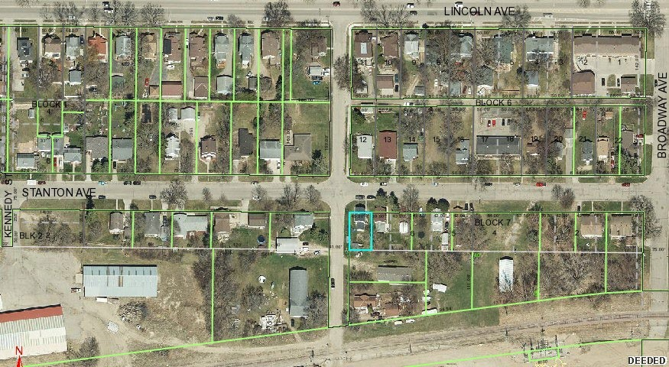

*The parcel is outlined in blue in the image above.*

Zoning Map for 647 W Stanton Ave

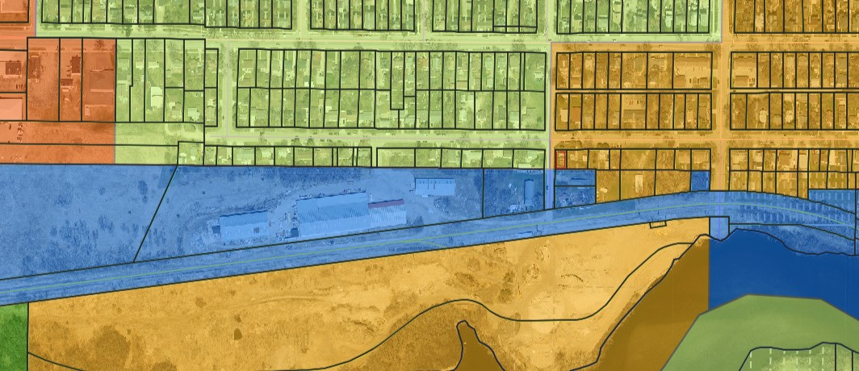

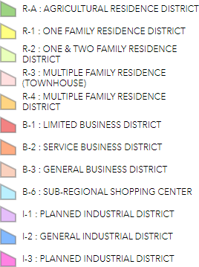

**efgtlsFalls**

*Minn,so/o*

*112 West WashingtonAvenue Fergus Falls, MN 56537 Phone: 218-332-5434*

*e-mai I. planning @ci.(ergus-falls.mn.us*

[*www.ci.fergus-falls.mn.us*](http://www.ci.fergus-falls.mn.us/)

**Variance**

*Application fee should be made payable to The City of Fergus Falls upon submittal of completed application. Please complete the application by typing or printing in ink. Use additional paper if necessary.*

1. **Property Owner Information:**

*Company name: _*

*Last name:* -\--\(1.\\D.("\ *First name:* ,o..x::5':tha cJ. TrO"-J

*Address:* (.d--\7 rtcn e

*fec0,b*

*)*

flo537

*Phone number:* **ZJB '105·BJC\L(** *Email address:* **-\'"Y'(l\\Co1.(ii)** \l .ccYV\

*City/State/Zip:*

fc,\\S N\N

1. **Applicant Information:** *(if different from above)*

*Company name: _ Last name: First name: Address: City/State/Zip: _*

*Phone number: Email address:*

1. **Address(es) of Property Involved:** *(if different from above)*
2. **Zoning Designation:** _
3. **Statement of Intent:** State exactly what is intended to be done on or with the property which does not conform to City Code requirements.

\NC1i1\d *\,t.e ::\:0* ?J:t LQ *a* Z.L\ X *?:/../J rfXotcJE.*

**7. Additional Required Information: a. Legal Description and PIN:** Provide the Parcel Identification Nurnber(s) _Jo_\o_3_'\<\.., o"'""°'-'---'-"ao=u _

**The complete legal description(s) of the property involved or write "see attached"**

*:'jeg_,* a.-¼ *che* d

**b. Practical Difficulty:** The applicant should fully explain the "practical difficulty" that justifies the departure from the strict application of the Code.

1. Is the variance in harmony with the general purposes and intent of the ordinance?
2. Is the variance consistent with the comprehensive plan.- Not Applicable, no city plan.
3. The property owner proposes to use the property in a reasonable manner not permitted by the zoning ordinance?

Y<5 *pw* '1 '=> --b *pu.¼- 0--* NGw *ga-40-91-*

1. The plight of the landowner is due to circumstances unique to the property not created by the landowner?

'je,.S 'A- ,5 a...stn:,,\\.e.v: lot rn':\.-N akhr *5Ce,+tc--* cJ..-

...\ov;>v--, kA- fut:\- Sr<b 1S *nt>+* a\ \a:Ld:J ::fa ha .t<---

LLwiJt: '::>' *1* )) gv-e%e.

1. The variance, if granted, will not alter the essential character of the locality?

Ne, 'id: u"·, \I.. i11o+-- --,+ *'"(,\* YV'D..Y&r± lool:: n *,c£*r 0.47d

g,v;.- V\'\,&,, ofC 3:b{uL\; (21-< l *ac,* 1;,JY\IO:\ _, *ch* O l:Jc:.:&

1. Economic considerations alone do not constitute practical difficulties, are there other reasons for the need for the variance?

**c. Proposed Plans:** A site plan is required, a landscape plan, grading and drainage plan and other plans may be required by the city/planning commission. Such plans shall be on 8½"x **11"** or 11"x 17" paper or in PDF digital format. In cases of multiple variances, the applicant may be required to submit a property boundary and building survey.

**8. Signature(s):** By signing below, you attest that the information above and attached is true and correct to the best of your knowledge.

***Properly Owner"J;;;xi.o&IJlor-,_***

*Applicant:*

*Date: {JJ-* 8:-*c;)OcJ* .3

*Date: Le.* - *r d.{)a.* 3

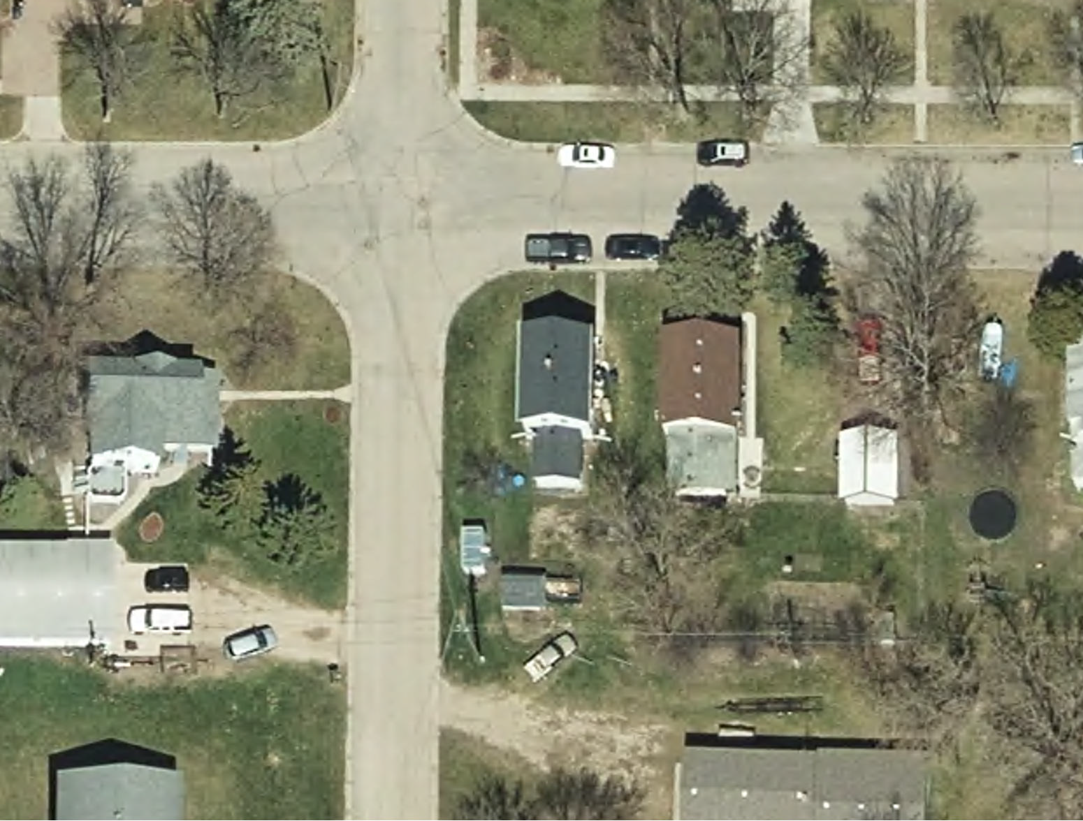

®

**Variance-Garage-647 Stanton Ave West**

**STANTON AVE WEST**

# 45.00' +/-

7 6

**24' x 36' Garage**

75.50' +/-

**6' 3'**

**3'**

**BUSE ST SOUTH**

**Legend**

647 Stanton Ave West Garage Lot Boundary

NO SCALE 6/12/23

Municipal Boundary

Firefox https://ottertail.visualgov.com/Property/Prim

**Otter Tail County**

**Property Information, Owner, Legal Description, and Assessed Values displayed below are taken from the Tax Statements (good as of the date the tax statements were printed).**

**The Taxes, Special Assessments, Penalty, Interest, Paid To Date, Balance Due, Installment, Receipt information, and History is live information (accessed live from the County's Tax System dynamically).**

- **Property Information**- ·

**Parcel Number 71003990986000**

**Property Address**

i 647 W STANTON AVE FERGUS FALLS

**Payable Year: 2023**

**Tax Roll Type:** Real Estate

**Jurisdiction** : FERGUS FALLS CITY

**School District:** FERGUS FALLS ISD 544

- **Owner Information** -

I **Primary Taxpayer/Owner**

TABITHA HALLAN ET AL

647 STANTON AVE W

I FERGUS FALLS MN 56537-2509

**Escrow Information**

Escrow Agent: CENLAR FEDERAL SAVINGS BANK

*¥("* **-Legal Description·** ·-

Sect-34 Twp-133 Range-043 MCLANE'S ADDN W 45' OF LOT 7 BLK 7

**Plat:** 00955

Real Estate and Personal Property Taxes are determined using the previous year assessment value. Mobile Home Taxes are determined using the current year assessment value.

1 of3 6/8/2023, 12:05 PM

Firefox https://ottertaiLvisualgov.com/flroperty/Print

\*\**Additional reductions in taxable value may apply due to special tax deferrals, This Old House, Plat Laws, etc.*

**Property Classification:** RES HMSTD

- **Assessment Year,-·** --- ·- --- r ·**Payable Year·**

Est. Market Value - Total $54,800 1 Total Tax

$426.00

'j Taxable Market Total $32,900 ; ,

.. ,........ ',... , .....,,,,..... .. ......... . . .. - ! !

**Special Assessments** PAYABLE_2023SOLIDWA$TE FEE

$80.00

Penalty $0.00

Interest $0.00

Fee $0.00

Tax/Asmts $506.00

Total $506.00

Paid To Date $253.00

**Unpaid Balance $253.00**

**Installments· Installments**

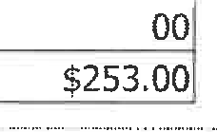

$0.

**Due Date**

**Due Amount**

iTaxes/Assessments 1st Half 05/15/2023

!Taxes/Assessments 2nd Half 10/16/2023



**·Receipts·** --.

j ..

**Receipt#**

 1734979

**Date**

05/05/2023

**Amount**

$253.00



·**History..-·**

,,,,._ - --, ------------ .., - ---

**Payable Year**

**Tax**

**Special Penalty**

**Assessment Interest & Fees Amount Paid**

**Total Due Add To**

**cart**

|  |  |  |  |  |  |  |
| --- | --- | --- | --- | --- | --- | --- |
| 2022 | $640.00 | $70.00 | $0.00 | $710.00 | $0.00 | Paid |
| 2021 | $576.00 | $70.00 | $0.00 | $646.00 | $0.00 | Paid |
| 2020 | $574.00 | $70.00 | $0.00 | $644.00 | $0.00 | Paid |
| 2019 | $556.00 | $70.00 | $0.00 | $626.00 | $0.00 | Paid |

2 of3 *6!8/2023,* 12:05 PM

CITY ADMINISTRATOR'S OFFICE

Fergus Falls, Minnesota 56537

Receipt# 229924

Received From TABITHA HALLAN

Receipt Date

Amount

June 08, 2023

$350.00

!Fund I Account I Description I Amount I l-----l-----------1---------------------------------I 1

/ 101 / 34103 000 / LAND VARIANCE/647 W STANTON / 350.00 /

City of Fergus Falls

Received By V-'-"'-I=C=K=I=E ------------

